English Draughts
By Deren Vural (160009020) and Gregor Taylor (160012442)

In this assignment, we chose to make English Draughts, which is a variant of the popular strategy board game Checkers. We also decided to add international draughts as we had time spare at the end and thought it would be a worthwhile feature to add. The game involves two colours of checker pieces which are placed onto a board that consists of two different colours of tile. The game is played by two players who each get one colour of piece and take turns in making moves. The aim is to capture all of your opponent’s pieces and therefore win the game.
One Problem which occurred was implementing the reset feature when a player had won the game or the player was wanting to quit a game and start again. We had several problems with this, including the game taking away rows of the board, and pieces disappearing after they had been moved. We had to search for ways to remove the whole 2D array of the tiles as we found that previously it had not been removing it all and therefore causing problems in the new game. We eventually managed to find a solution to this problem using Stack Overflow- (“https://stackoverflow.com/questions/27910364/remove-all-buttons-from-panel”)
A second problem which we encountered was when we when trying to implement the different board sizes. When changing the board size the game window would be wider than wanted, which made the game look less neat on screen. To solve this, we had the program explicitly define the size of the form and position of the player labels according to the board size each time a new game was started.
When implementing the program we realised that 4 common takes, involving jumping 2 pieces diagonally, would be very common. To improve the HCI of this operation, we allowed the player to click on just the moving piece and the destination, with the game checking if this long-take was valid. In the future we would have liked to also add this for more awkward long-takes, and even program the game to handle taking an unknown number of pieces in one click.
In Terms of future ideas for our game, there are several possible features that could be implemented. One future extension would be to add a feature where the user gets the option to either play against another user or to play against the computer, instead of just playing against another user. This could then have different difficulty levels, using a system of handicaps, levels of aggression and known draughts tactics.

Game Design: For our design, we decided to use the English draughts format of checkers which uses a board of 8 tiles wide and 8 tiles tall. We also decided to use red and black pieces for the players as these colours are very common in checkers and also stand out against each other and the colours that make the board. We also decided to add colour to the users name whose turn it was, therefore making it easier to distinguish and remove any confusion from the matter. We also increased the size of the names to make it even clearer. We chose to add background music to the game to give it more of an arcade game feel. Additionally adding a sound effect when one of the players won the game. We would have also liked to have added a sound effect when a player jumps over an opponent’s piece to alert the player that a piece had been taken, however adding this made our background music stop playing so we decided to not add this feature. Late in the implementation we also decided to add an international draughts sized board (10 tiles by 10 tiles).

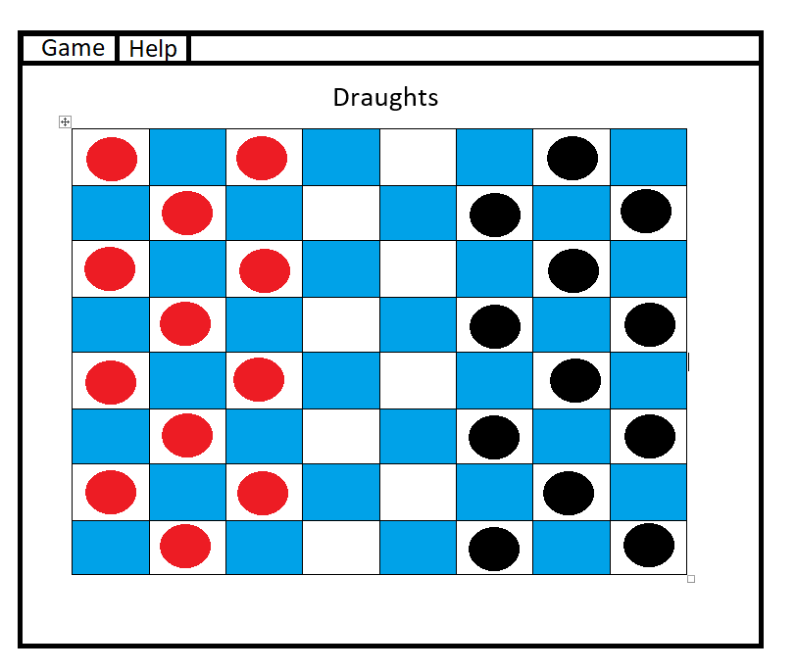
Name 1
Name 2

Game Rules:
A move: A simple move consist of a player moving one of their pieces diagonally onto an adjacent unoccupied white tile. Once a piece becomes a Crown it can not only move forward but backwards as well.
A jump: A jump consists of moving a piece which is diagonally adjacent to an opponent’s piece, to an empty tile directly beyond it in the same direction. When a tile has been jumped over, it is then removed from the game.
Multiple Jumps: A multiple jump is possible if after jumping an opponent’s piece, another piece is able to be jumped even if it is in a different diagonal direction.
Crowns: If a piece reaches the other end of the board it becomes a Crown, this gives the piece the ability to move both forward and backward.
End Game: A player can win the game by leaving your opponent with no legal next move or by having jumped and removed all of their pieces. The game will end as a draw if neither player can play a legal move.

Word Count: 486 (excluding Game Rules)

